**Exercise: Site Design Process**

**URL: octolist.web [October 😱 List]**

**Phase 1: Define Purpose**

1. Why does this site exist?
   * (You'll need to brainstorm a purpose right away for this exercise)
   * ***Off limits: One topic is off limits, be sure you're aware of this.***

A list of horror movies perfect of October to offer suggestions for good horror movies

1. What do you hope to achieve with it?

Showcase horror movies that are critically acclaimed, fan favorites, hidden gems, et cetera.

1. What's the Goal?
   * Write it out. We'll ask you for it at the end.
     + Decide before you move on.

Similar to the answer above - the goal is to give a comprehensive list of movies with filter options based on the type of movie and the ratings on different platforms.

**Phase 2: Consider Audience**

1. Who will be using your site?
   * Who is your target demographic?

People who are looking to discover something scary to watch.

The site will have to have a 18+ section/button for mature media, as a lot of the horror genre is under that category.

1. What are some characteristics of these users?

These users are interested in the horror genre and presumably enjoy watching movies. They probably aren’t horror experts, but the site should be designed for new and veteran horror enthusiasts alike.

1. What technology will they have?

The most likely use of OctoList will be from users sitting in a living room on a mobile device looking for something to stream. The site should feature well-organized responsive web design to account for this.

1. How might that affect your design?
   * Make some notes. We'll ask you about this in the end.

The main site would probably be devoid of blood and probably lean onto the halloween standard, with orange and dark purple. Pumpkins, ghosts, bats, and other trademark halloween entities would decorate. That way, even adolescents that are into horror can find films suitable for their age.

**Phase 3: Gather Ideas & Brainstorm**

1. Brainstorm further about what features/sections/content your site could have
   * List numerous ideas without being critical
   * An off-the-wall idea may help bring an excellent 'reasonable' idea to mind
   * Show (or link to) this brainstorming in your Slack Channel so that you instructor can see.
2. List features you came up with
   * Mature films are hidden from users who have not verified age
     + 18+ button with pop up warning that allows mature films to be shown in the search
   * Filter based on style of movie (slasher, paranormal, etc)
   * Filter based on year of release
   * Filter based on ratings from different credible sources (Rotten Tomatoes, IMDB)
   * List of all-time best horror movies maintained year-round.
   * Yearly article posted during the halloween season that retrospect the past year’s horror movies and speculate on future movie releases.
3. Examine other sites.
   * What additional ideas did this bring to mind?
   * IMDb- Critic reviews and comments could be a useful feature for community engagement
   * Video players with the trailer for each film
   * Allow for community comments/review
   * Tags for each movie for users looking for specific stuff ie. Slasher, Thriller, Gore, Supernatural
   * Profiler - have users fill out preferences so that the site recommends titles that fit their preferences and can save previously watched movies
   * Thumbnails of movie covers
4. Ask potential users (if you can find some).

**Phase 4: Organize Ideas**

1. Take each idea and consider them
   * Do they help the goals of the site defined at the beginning?
   * Seek maximum impact with minimum resource consumption
2. Sort ideas into categories
   * Select the ideas that supported the goal most clearly and group them into categories.
   * Show the results of this grouping/culling (or link to it) in your Slack Channel so that your instructor can see.
   * Sorting
     + Filter based on style of movie (slasher, paranormal, etc)
     + Filter based on year of release
     + Filter based on ratings from different credible sources (Rotten Tomatoes, IMDB)
     + Tags for each movie for users looking for specific stuff ie. Slasher, Thriller, Gore, Supernatural
   * Social
     + Yearly article posted during the halloween season that retrospect the past year’s horror movies and speculate on future movie releases.
     + List of all-time best horror movies maintained year-round.
     + Profiler - have users fill out preferences so that the site recommends titles that fit their preferences and can save previously watched movies
     + Allow for community comments/review
     + IMDb- Critic reviews and comments could be a useful feature for community engagement
   * 18+ Filter
     + Mature films are hidden from users who have not verified age
     + 18+ button with pop up warning that allows mature films to be shown in the search
   * Visual
     + Purple and orange website color palette
     + Pumpkins, ghosts, bats, and other trademark halloween entities
     + Video players with the trailer for each film
     + Thumbnails of movie covers

**Phase 5: Determine Navigation**

1. How should this be organized?
   * By category?
   * By date?
   * By alphabetical order?
   * Others?
   * Categories of horror films
2. Draw a conceptual diagram. Note that the website <http://diagrams.net> could be very useful for both this step and the next Phase, but you are not required to use it. Think boxes with lines between showing connections. It does not need to be extensive.

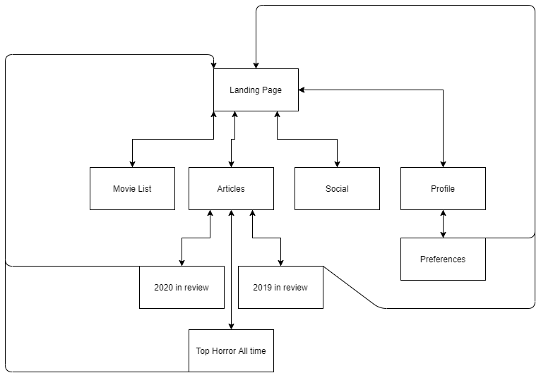

**Phase 6: Sketch Pages**

* Create two pages of rough sketches for your design. If you were to do it in <http://diagrams.net> we'd be expecting something no fancier than the kind of drawings you might find in the Wireframes section. In a normal semester when all students are in-person we'd normally surprise the students with paper and crayons to draw with. We aren't expecting anything fancier or more time consuming than that.
* We would like to see a Front Page of your site and an example of one deeper level than that -- an article page, an item page, an entry on your site... whatever makes the most sense as a "main" deeper-than-front-page item on your site. So, two sketches.

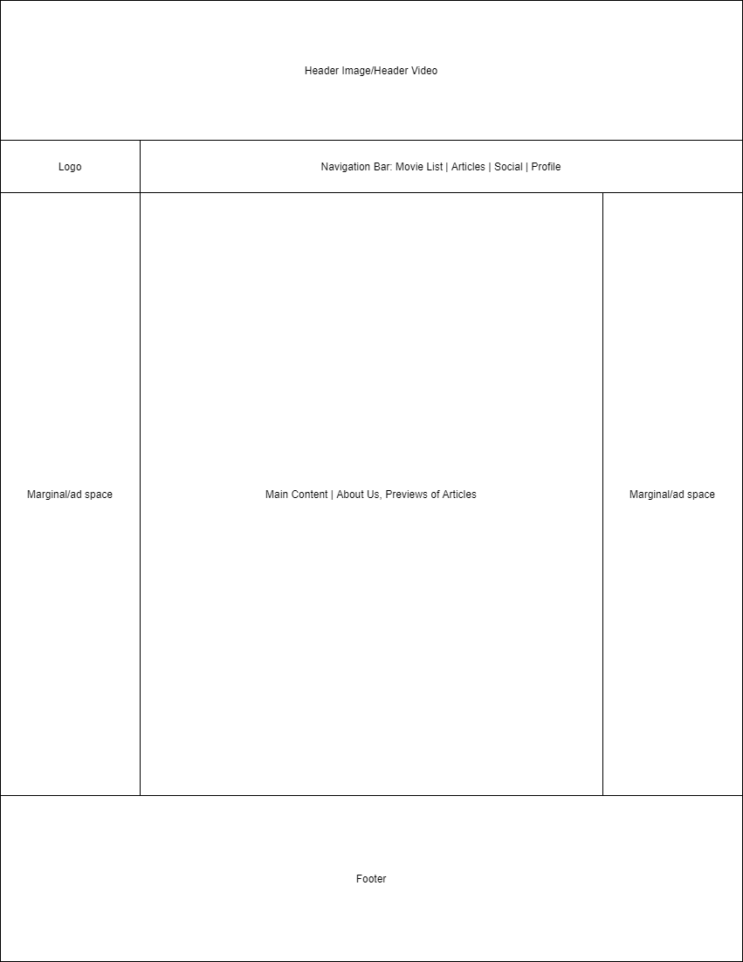

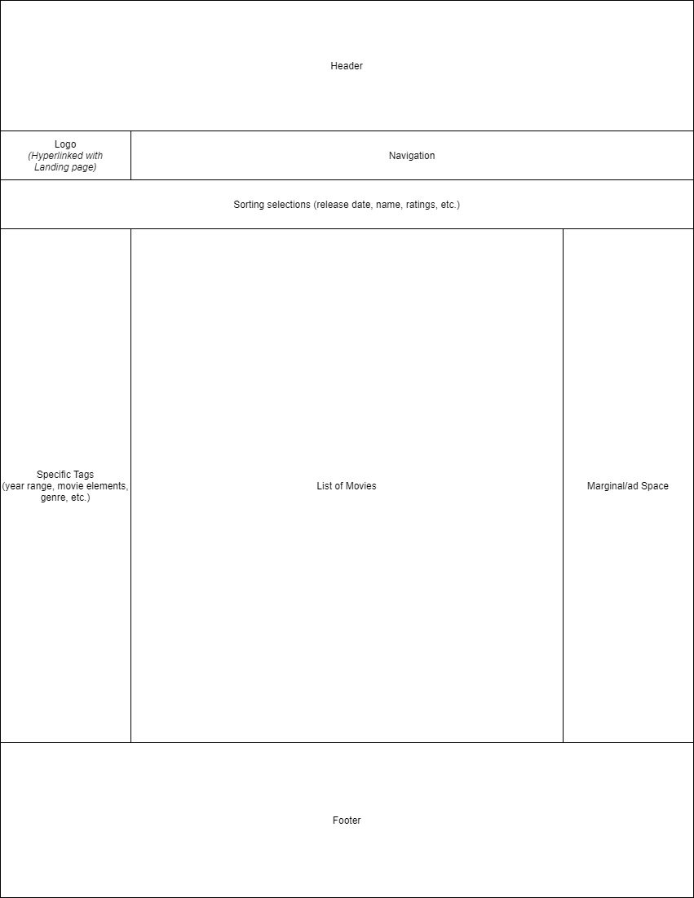

**Phase 7: Present Design to the Class**

* You will post your design for all sections of the class to look at any time AFTER Thursday October 1st and before your next in-person Lab. Online/Flex sections: Your Instructor will post the expectations for when this should be posted to your Section-Specific channel.
* It should be posted to the *#exercise-sitedesign* channel and should follow the format of the Pinned Post. Remember that you can enter multiple lines or bullet points in a post by using shift-enter to separate lines.